**Accurate Body Fat Prediction**

Using Machine Learning

Developed By: Ch chandra shekhar, G. Vamsee Mourya, G.V. Meghana, A. Guna.

**Smart Bridge Project Report - Applied data science**

**1.INTRODUCTION**

**1.1 OVERVIEW:**

The project aims to develop a machine learning model for accurate body fat prediction. Body fat percentage is an important health indicator, and accurate estimation can be beneficial in various domains such as healthcare, fitness, and nutrition.

The project involves training a machine learning model on a dataset that includes body fat measurements and corresponding features such as age, gender, height, weight, and body measurements. Through the learning process, the model captures complex relationships between these features and body fat percentage, enabling it to make accurate predictions for new individuals. By accurately estimating body fat percentage, the model can assist individuals in monitoring their health and fitness goals, support healthcare professionals in assessing patients' health risks, and contribute to research studies exploring the impact of body fat on various health outcomes.

**1.2 Purpose:**

The purpose of this project is to overcome the limitations of traditional body fat measurement methods and provide a non-invasive and efficient solution using machine learning algorithms. The model will utilize easily measurable features to predict body fat percentage accurately.

The project's purpose is to provide a valuable tool for healthcare professionals, fitness enthusiasts, and individuals who seek to monitor and manage their body composition. Accurate body fat prediction can assist healthcare professionals in assessing patients' health risks, designing personalized treatment plans, and monitoring the impact of interventions. For fitness enthusiasts and individuals, it can offer insights into their body composition progress, guide exercise and nutrition choices, and help set realistic fitness goals. The project's purpose is to contribute to the field of body composition analysis by leveraging machine learning techniques to enhance the accuracy, efficiency, and accessibility of body fat prediction, ultimately improving health outcomes, and promoting overall well-being.

**2. LITERATURE SURVEY**

**2.1 EXISTING PROBLEM:**

The existing problems in accurate body fat prediction include the limitations of simplistic metrics like BMI and the lack of convenience and accessibility of advanced measurement techniques. Addressing these problems through machine learning can improve the accuracy, convenience, and availability of body fat estimation, leading to better health assessments and personalized interventions.

Existing approaches for body fat prediction may involve anthropometric equations, skinfold measurements, or bioelectrical impedance analysis. These methods have limitations in accuracy, invasiveness, or time consumption.

**2.2 PROPOSED SOLUTION:**

The proposed solution involves using machine learning algorithms to create a model that accurately predicts body fat percentage. By analysing a dataset of body fat measurements and relevant features, the model will learn patterns and relationships to make accurate predictions.

The solution focuses on enhancing the accessibility and convenience of body fat prediction by leveraging machine learning algorithms. By utilizing commonly available features and avoiding the need for specialized equipment or invasive procedures, the proposed solution can be easily integrated into healthcare settings, fitness applications, or personal devices. This would enable individuals to access accurate body fat predictions conveniently, facilitating regular monitoring of their body composition and supporting informed decision-making regarding their health and fitness goals.

**3. THEORITICAL ANALYSIS**

**3.1 BLOCK DIAGRAM:**

**LOGISTIC REGRESSION:**

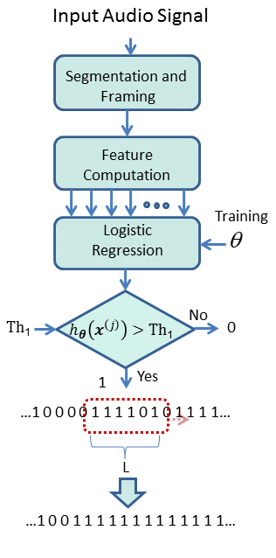

**LINEAR REGRESSION:**

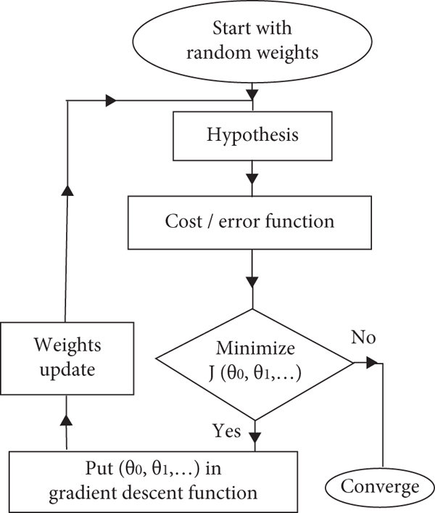

**3.2 HARDWARE/SOFTWARE DESIGNING:**

To ensure smooth execution of machine learning models, it is recommended to have a system with a minimum of 16 GB RAM and a powerful processor to handle the computational requirements. Additionally, the following software requirements are necessary:

1. **Jupyter Notebook:** Jupyter Notebook is a popular programming environment for data analysis and machine learning. It is recommended to install Jupyter Notebook as part of the Anaconda distribution, which provides a comprehensive package manager and simplifies the installation process.
2. **Python Packages:** Python is the programming language commonly used for machine learning. Ensure that the required Python packages are installed, such as NumPy, Pandas, Scikit-learn, TensorFlow, or PyTorch, depending on the specific requirements of your project. These packages provide essential functionalities for data manipulation, model training, and evaluation.

**3.3 EXPERIMENTAL INVESTIGATIONS:**

* Determine whether the dataset has any null values.
* Determine whether it contains numerical or categorical features.
* Dataset segmentation into dependent and independent features
* Find out the Correlation between the features
* Split the dataset into Training and Testing data.

**4.FLOWCHART:**

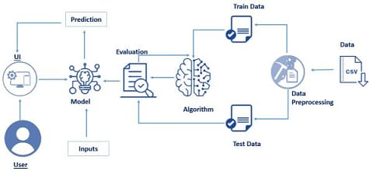

**5. RESULT:**

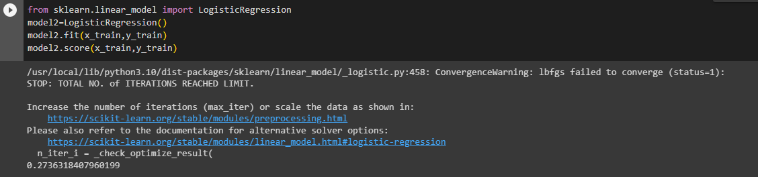

**Logistic Regression**

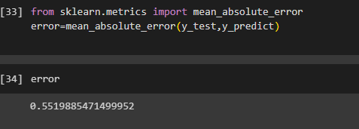

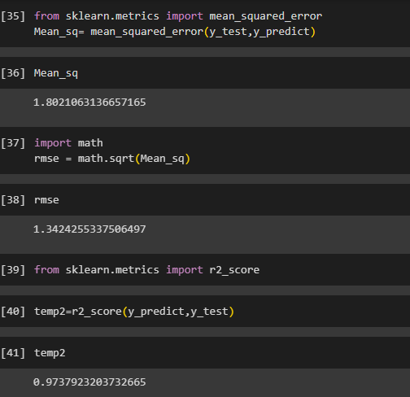

**6.ADVANTAGES & DISADVANTAGES:**

**Non-invasive:** The proposed solution offers a non-invasive method for estimating body fat percentage, eliminating the need for invasive procedures. This makes the process more convenient, cost-effective, and less time-consuming for both healthcare professionals and individuals seeking to monitor their body composition.

**Accuracy:** The machine learning model aims to improve accuracy compared to traditional methods by leveraging patterns in the data.

**Efficiency:** The model provides a faster and more efficient approach to body fat prediction, allowing for quick and reliable results. The accuracy of body fat prediction is significantly improved compared to traditional methods like BMI or caliper measurements, which often rely on generalized formulas or assumptions.

In summary, accurate body fat prediction using machine learning offers advantages of enhanced accuracy and convenience. By leveraging large datasets and learning complex patterns, machine learning models can provide more accurate predictions compared to traditional methods. Additionally, the non-invasive nature of machine learning-based prediction makes it a practical and accessible tool for assessing body fat percentage, benefiting both healthcare professionals and individuals managing their health and fitness.

**Disadvantages:**

**Dependence on training data quality:** The accuracy of the model relies on the quality and diversity of the training dataset. Inadequate or biased data may affect the model's performance.

**Sensitivity to feature selection:** The choice and relevance of input features can impact the accuracy of the model. Careful feature selection and engineering are crucial for optimal performance.

while accurate body fat prediction using machine learning has many advantages, it is essential to be mindful of the limitations. Biases in the training data and the challenge of generalization to diverse populations can impact the accuracy and reliability of the predictions. To mitigate these disadvantages, it is crucial to carefully curate the training dataset and regularly update it to reflect the diversity of the target population. Additionally, ongoing research and improvement in machine learning algorithms can help address these limitations and enhance the performance of body fat prediction models.

**7.Applications:**

Accurate body fat prediction using machine learning has various practical applications in different domains. The following are some key applications:

**Healthcare:** Accurate body fat prediction can assist healthcare professionals in assessing patients' health risks, monitoring obesity-related diseases, and designing personalized treatment plans. This application aids in providing personalized healthcare plans and monitoring the effectiveness of interventions.

**Fitness and nutrition:** Individuals can utilize the model to track their body fat percentage and make informed decisions regarding exercise, diet, and weight management. By leveraging machine learning models, individuals can make informed decisions about their diet, exercise routines, and overall lifestyle to achieve optimal body composition and overall health.

**Research and sports:** The model can be used in research studies to investigate the relationship between body fat percentage and various factors. It can also aid athletes and sports professionals in optimizing performance and monitoring body composition. This application helps athletes enhance their performance, improve endurance, and reduce the risk of injuries.

These applications demonstrate the wide-ranging benefits of accurate body fat prediction using machine learning, empowering individuals, healthcare professionals, athletes, and researchers to make informed decisions, optimize performance, and improve overall health and well-being.

**8. CONCLUSION:**

So, from this project we would love to conclude that, we used two regression algorithms from machine learning to predict the accuracy and probability of the events. Here in this dataset, it may sound abrupt to call it as events but rather predictions would be accurate. So, the first algorithm that we used is the regression algorithm that is logistic regression and the second one is the Linear regression. The logistic regression is used for the prediction of result using the data which we gave to the model while the linear regression is used to predict the accuracy of the dataset using an additional attribute that is label in this case. So finally using the two regression methods we finally finished the project and here are the following conclusions from the projects.

**9.FUTURE SCOPE:**

Accurate body fat prediction using machine learning has a promising future with several potential areas for improvement and expansion. The following are some key future scope aspects:

**Incorporating additional features:** Exploring the inclusion of more features, such as lifestyle factors or genetic information, to improve the accuracy of the model. This would enable more comprehensive and accurate body fat prediction by capturing additional physiological and morphological features.

**Mobile application development:** Creating a user-friendly mobile application that allows individuals to easily track and monitor their body fat percentage. These techniques have shown great potential in other domains and could potentially improve the predictive capabilities of body fat estimation models.

**Integration with wearable devices:** Integrating the model with wearable devices or smart scales to provide real-time body fat estimation and personalized recommendations. Integration with wearable devices and health platforms can further enhance the user experience and enable seamless monitoring.

**Longitudinal Studies and Health Outcomes Analysis:** Future studies can explore the long-term impact of accurate body fat prediction on health outcomes. This research can provide valuable insights into the relationship between body composition and health outcomes.

In conclusion, the future scope of accurate body fat prediction using machine learning involves the integration of advanced techniques, incorporation of new data sources, development of user-friendly applications, personalized interventions, and analysis of long-term health outcomes. These advancements would contribute to the continuous improvement and practical implementation of accurate body fat prediction models in various fields related to health, fitness, and research.

**10. BIBILOGRAPHY:**

[**https://www.researchgate.net/figure/Flow-chart-of-linear-regression_fig2_357292132/download**](https://www.researchgate.net/figure/Flow-chart-of-linear-regression_fig2_357292132/download)

[**https://www.researchgate.net/figure/Flow-chart-of-linear-regression_fig2_357292132**](https://www.researchgate.net/figure/Flow-chart-of-linear-regression_fig2_357292132)

[**https://towardsdatascience.com/linear-regression-using-python-b136c91bf0a2**](https://towardsdatascience.com/linear-regression-using-python-b136c91bf0a2)

[**https://www.analyticsvidhya.com/blog/2021/10/everything-you-need-to-know-about-linear-regression/**](https://www.analyticsvidhya.com/blog/2021/10/everything-you-need-to-know-about-linear-regression/)

[**https://www.javatpoint.com/linear-regression-in-machine-learning**](https://www.javatpoint.com/linear-regression-in-machine-learning)

[**https://www.geeksforgeeks.org/ml-linear-regression/**](https://www.geeksforgeeks.org/ml-linear-regression/)

[**https://www.javatpoint.com/logistic-regression-in-machine-learning**](https://www.javatpoint.com/logistic-regression-in-machine-learning)

**11. Appendix: -**

from google.colab import drive

drive.mount('../content/drive')

import numpy as np

import pandas as pd

import matplotlib.pyplot as plt

dataset=pd.read_csv('../content/drive/MyDrive/Colab Notebooks/bodyfat.csv')

dataset.head()

df1=dataset.drop(['Density'],axis='columns')

df1.head()

df1.shape

df1.isnull().sum()

dummies=pd.get_dummies(df1.Age)

dummies

df2.Age.unique()

x=df1.drop('Age', axis='columns')

x.shape

y=df1['Age']

y.shape

from sklearn.model_selection import train_test_split

x_train, x_test, y_train, y_test = train_test_split(x,y,test_size=0.2,random_state=20)

from sklearn.linear_model import LogisticRegression

model2=LogisticRegression()

model2.fit(x_train,y_train)

model2.score(x_train,y_train)

dataset.info()

dataset

dataset.isnull().sum()

from sklearn.preprocessing import LabelEncoder

label=LabelEncoder()

dataset['label'] = label.fit_transform(dataset["Age"])

x=dataset.drop(['BodyFat','Age'],axis=1)

x

y=dataset['BodyFat']

y.unique()

x.shape,y.shape

from sklearn.model_selection import train_test_split

x_train, x_test, y_train, y_test = train_test_split(x, y, test_size=0.2, random_state=20)

x_train.shape, y_train.shape

x_test.shape,y_test.shape

from sklearn.linear_model import LinearRegression

model=LinearRegression()

model.fit(x_train,y_train)

y_predict = model.predict(x_test)

y_predict

from sklearn.metrics import accuracy_score

input= [[28.43,6.56,3.56,7.00,9.87,8.98,6.87,16.88,24.44,31.09,19.12,14.79,29.33,0]]

temp=model.predict(input)

temp

from sklearn.metrics import mean_absolute_error

error=mean_absolute_error(y_test,y_predict)

error

from sklearn.metrics import mean_squared_error

Mean_sq= mean_squared_error(y_test,y_predict)

Mean_sq

import math

rmse = math.sqrt(Mean_sq)

rmse

from sklearn.metrics import r2_score

temp2=r2_score(y_predict,y_test)

temp2